

# PROJECT: GROUP NO: BATCH:

# SYSTEM REQUIREMENTS:

1. **Hardware**:

**Web Server**

* Processor Intel Core I3 or higher.
* Memory 6 GB RAM or greater.
* Modem/ADSL Internet access is required.

**Client**

* Processor Intel Core I3 or higher.
* Memory 6 GB RAM or greater.
* Monitor Super VGA (1024x768) or higher resolution.
* Modem/ADSL Internet access is required.

1. **Software**:

**Server:**

* Operation System: Window 7 or later.
* Databases: MySQL.
* Java FX
* Git

**Client:**

* Operation System Window 7 or higher.
* Browser Google Chrome , MS-Edge, Firefox

# Install the database

1. Import file HotelManagement.sql to SQL Server Management Studio**:**

Step 1. Right click databases > Import Data-tier Application...

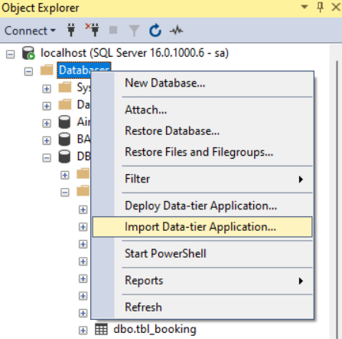

Step 2. Click Browse to select the location where the database file is stored

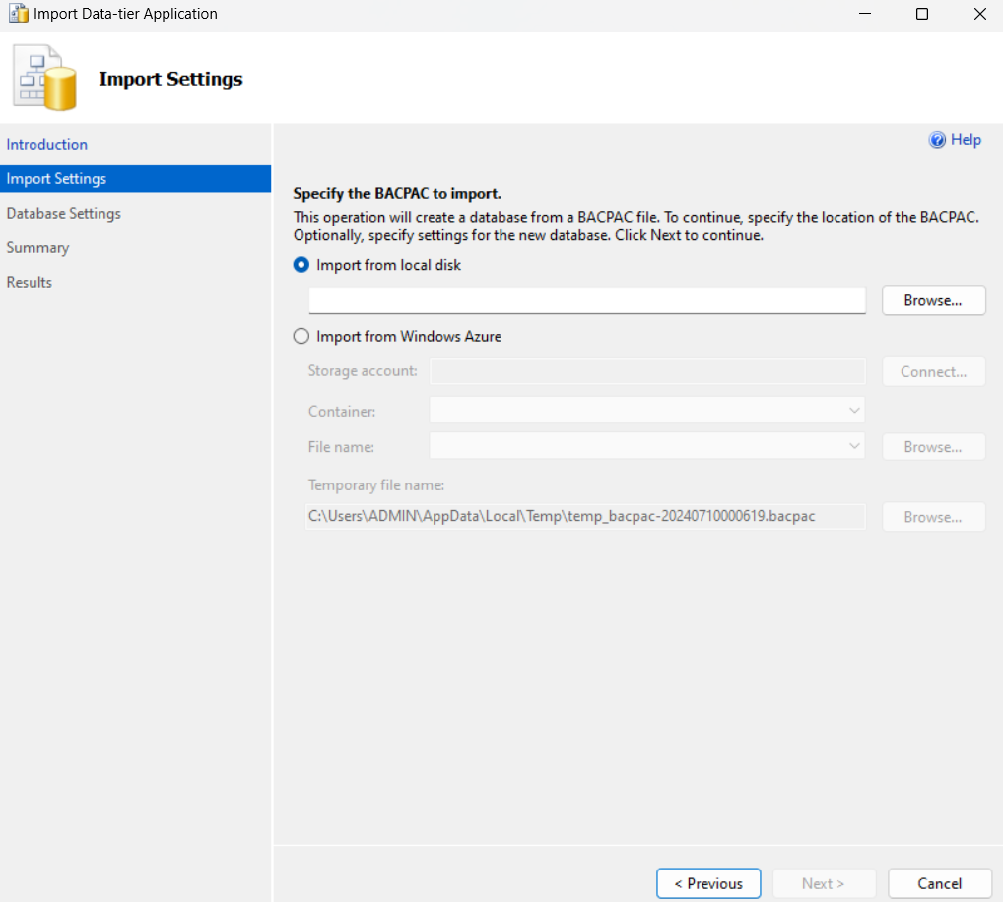

1. **Download project from GitHub:**

Step 1. Import project to Apache Netbeans

Step2. In Apache Netbeans click File > Import Project > From ZIP…

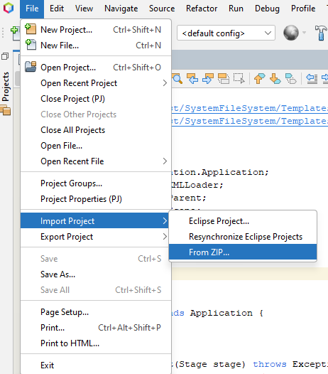

Step 3. Click Browse to select the location where the project file is stored

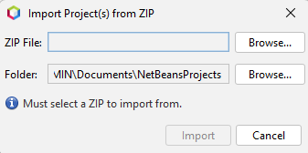

# C. Successful test

- The file is loaded successfully

- App is displayed.

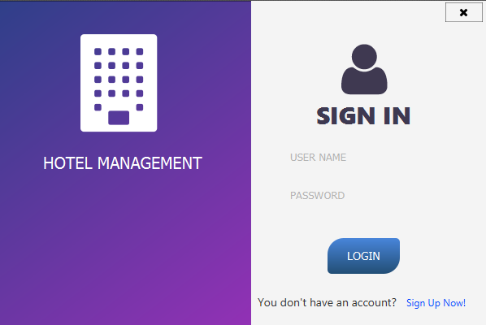

* Additional

Login account, use one of the following accounts:

|  |  |
| --- | --- |
| **Username** | **Password** |
| admin(admin) | 123456 |
| nhatnam(user) | 1 |
| user(user) | 123456 |